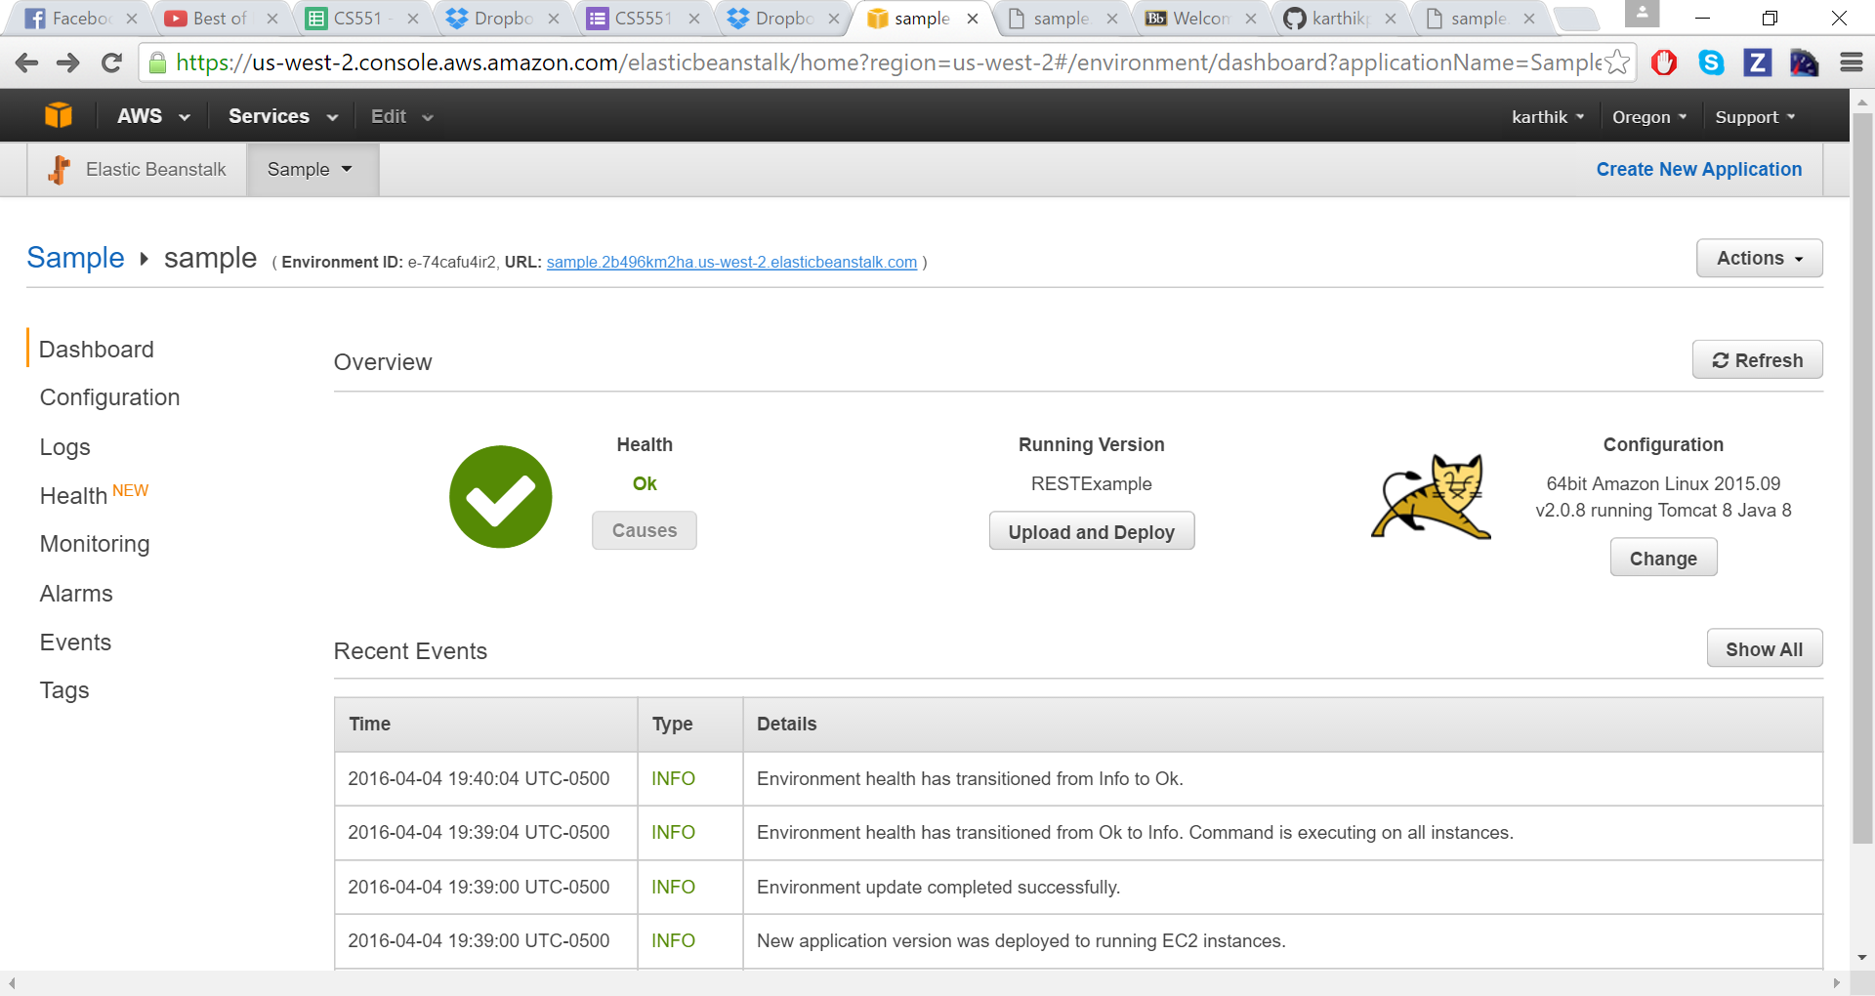Deployment Notification:

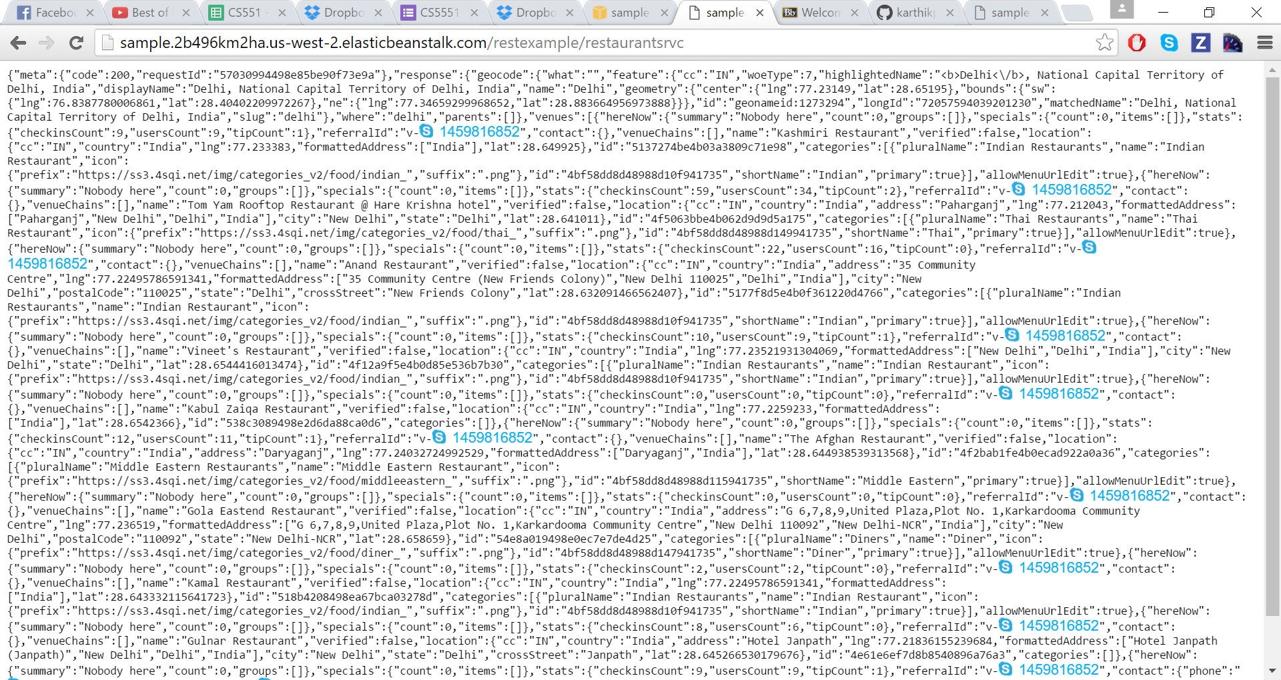Foursquare:

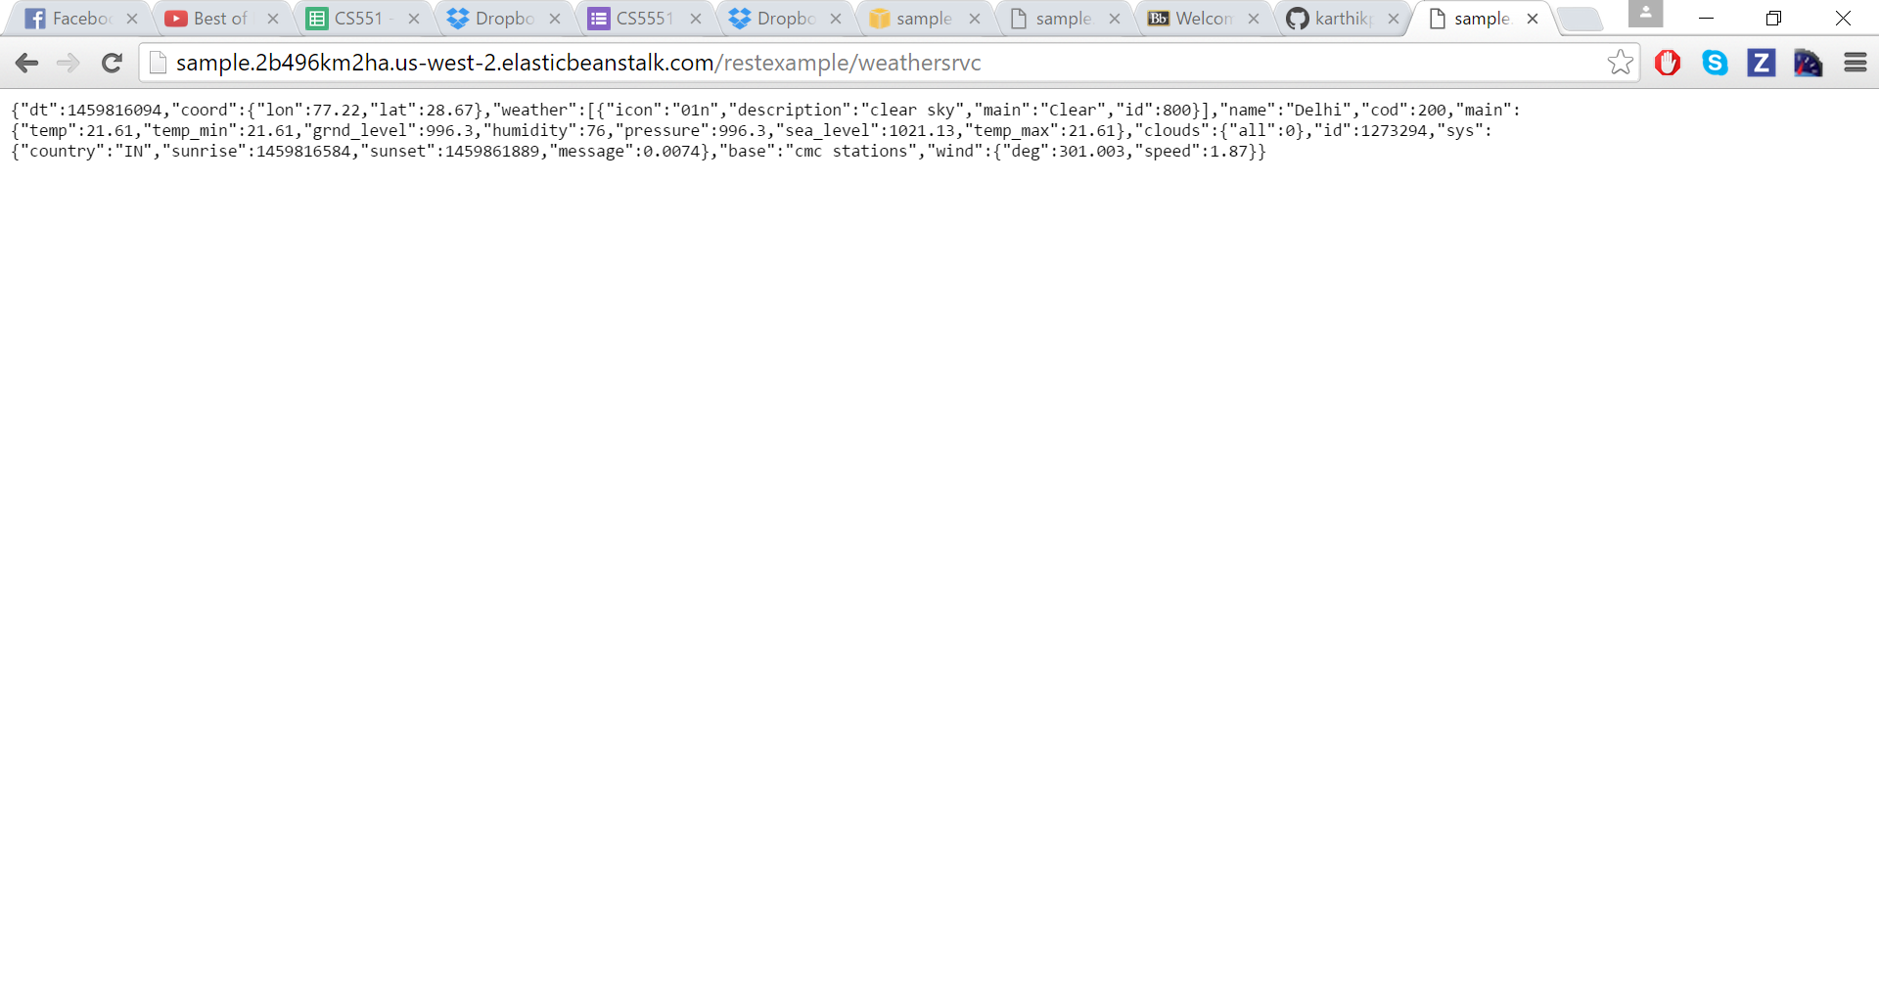Weather API:

AWS URLs:

* <http://sample.2b496km2ha.us-west-2.elasticbeanstalk.com/restexample/restaurantsrvc>
* <http://sample.2b496km2ha.us-west-2.elasticbeanstalk.com/restexample/weathersrvc>